wk1_assign_C_php.doc

*** Applying What You Have Learned! ***

Topic: Working with FORMS and Variables

Description: *“Using a Form to obtain information   
 from a User”*

Task #1: Create the Form “Jacketform.htm”

* Open your text editor;
  + Create the form shown below.
  + Use the POST method and call the “Jacketconfirmation.php” page when the form is submitted.
* Create the document as shown below;

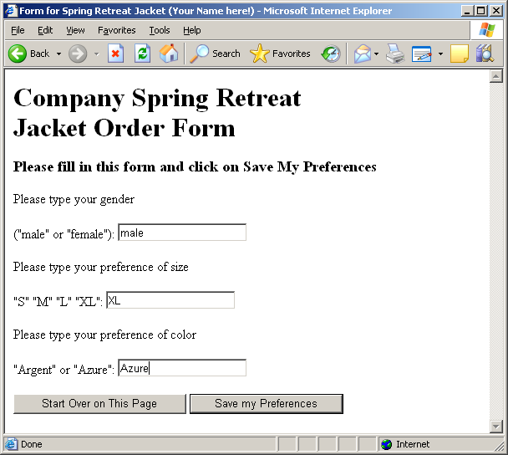

* + Save the document as: Jacketform.htm

Task #2: Create the “Jacketconfirmation.php” page

*When the form is submitted,* Jacketconfirmation.php *is executed and passed the value of the gender, size, and color text boxes from the form.*

* Open your text editor;
  + Create the PHP page that will display the text shown below, using the values entered into the form text boxes.
* When the form is submitted, the following page is displayed;

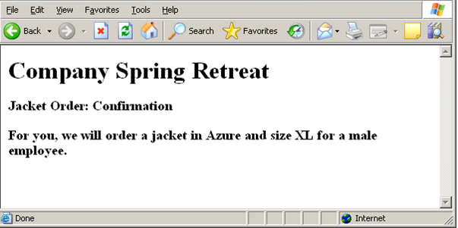

Changes:

* On the bottom of this page – display the text

“Programmed by: {your full name goes here}” in h2 font size.

* + Save the document as: Jacketconfirmation.php
* Post file Jacketform*.htm and* Jacketconfirmation.*php to* your college Web server.
* Open your browser and load the page to test your code.

wk1_assign_C_php1.doc